**Week-7**

**9.Create a React Application named “cricketapp” with the following components:**

**app.js:**

import React from 'react';

import ListofPlayers from './components/ListofPlayers';

import IndianPlayers from './components/IndianPlayers';

const App = () => {

const flag = true; // Change to false to test IndianPlayers

return (

<div>

<h1>Welcome to Cricket App</h1>

{flag ? <ListofPlayers /> : <IndianPlayers />}

</div>

);

};

export default App;

### **components/ListofPlayers.js**

javascript

CopyEdit

import React from 'react';

const ListofPlayers = () => {

const players = [

{ name: 'Virat', score: 90 },

{ name: 'Rohit', score: 65 },

{ name: 'Rahul', score: 72 },

{ name: 'Shreyas', score: 55 },

{ name: 'Hardik', score: 88 },

{ name: 'Jadeja', score: 60 },

{ name: 'Ashwin', score: 78 },

{ name: 'Bumrah', score: 45 },

{ name: 'Siraj', score: 66 },

{ name: 'Shami', score: 50 },

{ name: 'Gill', score: 95 }

];

const filteredPlayers = players.filter(player => player.score < 70);

return (

<div>

<h2>List of All Players:</h2>

<ul>

{players.map((player, index) => (

<li key={index}>{player.name} - {player.score}</li>

))}

</ul>

<h2>Players with Score Below 70 (Filtered):</h2>

<ul>

{filteredPlayers.map((player, index) => (

<li key={index}>{player.name} - {player.score}</li>

))}

</ul>

</div>

);

};

export default ListofPlayers;

**components/IndianPlayers.js**

javascript

CopyEdit

import React from 'react';

const IndianPlayers = () => {

const T20Players = ['Rohit', 'Virat', 'Surya'];

const RanjiPlayers = ['Shreyas', 'Ishan', 'Sarfaraz'];

const mergedPlayers = [...T20Players, ...RanjiPlayers];

const [odd1, even1, odd2, even2, odd3, even3] = mergedPlayers;

return (

<div>

<h2>Indian Players</h2>

<h3>All Merged Players:</h3>

<ul>

{mergedPlayers.map((player, index) => (

<li key={index}>{player}</li>

))}

</ul>

<h3>Destructured Odd & Even Players:</h3>

<p>Odd Players: {odd1}, {odd2}, {odd3}</p>

<p>Even Players: {even1}, {even2}, {even3}</p>

</div>

);

};

export default IndianPlayers;

**Output:**

When flag=True

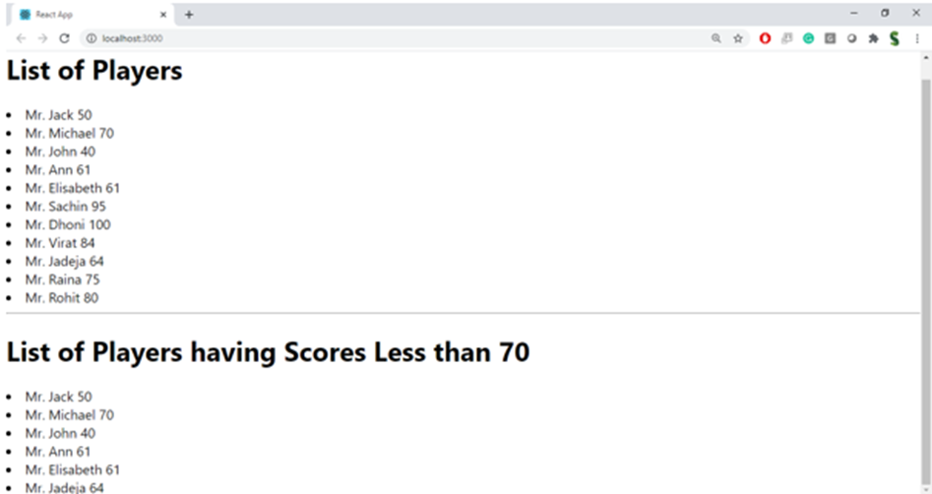

When flag = False

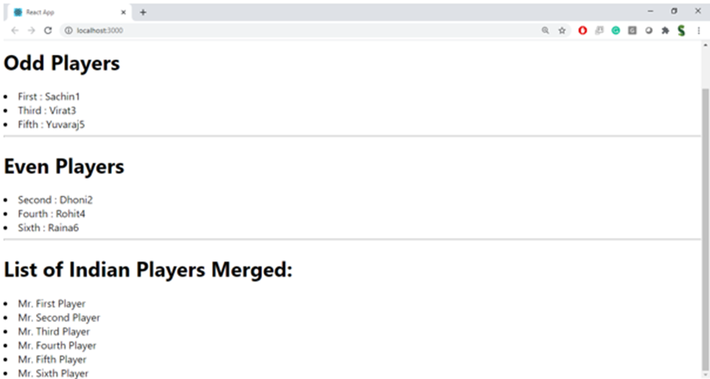

**10.Create a React Application named “officespacerentalapp” which uses React JSX to create elements, attributes and renders DOM to display the page.**

### **App.js**

javascript

CopyEdit

import React from 'react';

const App = () => {

const headingStyle = {

textAlign: 'center',

color: 'navy'

};

const imageStyle = {

width: '300px',

height: '200px',

borderRadius: '10px'

};

const offices = [

{

name: 'WeWork Tower',

rent: 55000,

address: 'MG Road, Bengaluru',

image: 'https://via.placeholder.com/300x200?text=WeWork'

},

{

name: 'Cowork Hub',

rent: 62000,

address: 'Hitech City, Hyderabad',

image: 'https://via.placeholder.com/300x200?text=Cowork+Hub'

},

{

name: 'OfficeNest',

rent: 45000,

address: 'Cyber Park, Gurugram',

image: 'https://via.placeholder.com/300x200?text=OfficeNest'

}

];

return (

<div>

<h1 style={headingStyle}>Office Space Rental App</h1>

{offices.map((office, index) => (

<div key={index} style={{ border: '1px solid gray', padding: '15px', margin: '20px', borderRadius: '10px' }}>

<img src={office.image} alt={office.name} style={imageStyle} />

<h2>{office.name}</h2>

<p><strong>Address:</strong> {office.address}</p>

<p style={{ color: office.rent < 60000 ? 'red' : 'green' }}>

<strong>Rent:</strong> ₹{office.rent}

</p>

</div>

))}

</div>

);

};

export default App;

**index.js**

javascript

CopyEdit

import React from 'react';

import ReactDOM from 'react-dom/client';

import App from './App';

const root = ReactDOM.createRoot(document.getElementById('root'));

root.render(<App />);

**Output:**

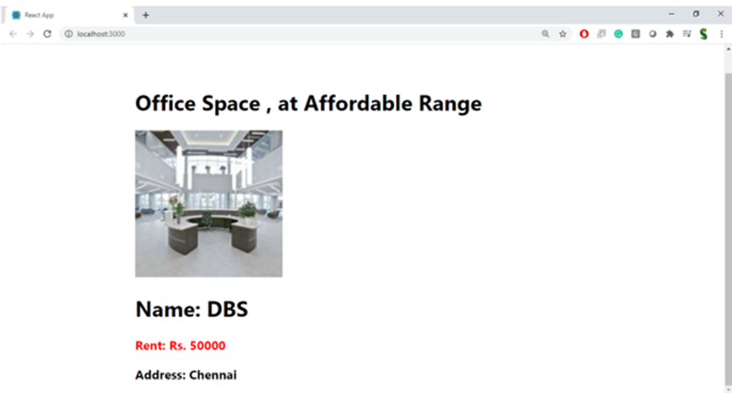

**11.Create a React Application “eventexamplesapp” to handle various events of the form elements in HTML.**

### **App.js**

javascript

CopyEdit

import React from 'react';

import CurrencyConverter from './components/CurrencyConverter';

class App extends React.Component {

constructor(props) {

super(props);

this.state = {

count: 0

};

}

increment = () => {

this.setState(prevState => ({ count: prevState.count + 1 }));

};

sayHello = () => {

alert('Hello! This is a static message ');

};

incrementAndGreet = () => {

this.increment();

this.sayHello();

};

decrement = () => {

this.setState(prevState => ({ count: prevState.count - 1 }));

};

sayWelcome = (message) => {

alert(`Welcome message: ${message}`);

};

handleSyntheticEvent = (e) => {

e.preventDefault();

alert('I was clicked (Synthetic Event) ');

};

render() {

return (

<div style={{ padding: '20px', fontFamily: 'Arial' }}>

<h1> Event Handling Example App</h1>

<h2>Counter: {this.state.count}</h2>

<button onClick={this.incrementAndGreet}>Increment</button>

<button onClick={this.decrement} style={{ marginLeft: '10px' }}>Decrement</button>

<div style={{ marginTop: '20px' }}>

<button onClick={() => this.sayWelcome('Hello from Event Handler!')}>Say Welcome</button>

</div>

<div style={{ marginTop: '20px' }}>

<button onClick={this.handleSyntheticEvent}>Synthetic Event Button</button>

</div>

<div style={{ marginTop: '40px' }}>

<CurrencyConverter />

</div>

</div>

);

}

}

export default App;

**components/CurrencyConverter.js**

javascript

CopyEdit

import React, { useState } from 'react';

const CurrencyConverter = () => {

const [rupees, setRupees] = useState('');

const [euros, setEuros] = useState('');

const handleSubmit = (e) => {

e.preventDefault();

const rate = 0.011; // Example conversion rate

const converted = (parseFloat(rupees) * rate).toFixed(2);

setEuros(converted);

};

return (

<div>

<h2>💱 Currency Converter (INR to Euro)</h2>

<form onSubmit={handleSubmit}>

<label>

Enter Amount in ₹ Rupees:

<input

type="number"

value={rupees}

onChange={(e) => setRupees(e.target.value)}

required

/>

</label>

<button type="submit" style={{ marginLeft: '10px' }}>Convert</button>

</form>

{euros && (

<p style={{ marginTop: '10px' }}>

Converted Amount in € Euros: <strong>{euros}</strong>

</p>

)}

</div>

);

};

export default CurrencyConverter;

**index.js**

javascript

CopyEdit

import React from 'react';

import ReactDOM from 'react-dom/client';

import App from './App';

const root = ReactDOM.createRoot(document.getElementById('root'));

root.render(<App />);

**Output:**

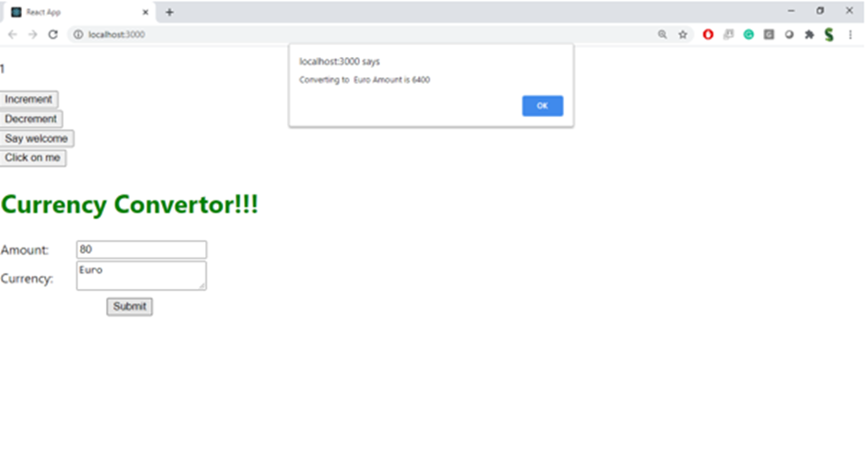

**12.Create a React Application named “ticketbookingapp” where the guest user can browse the page where the flight details are displayed whereas the logged in user only can book tickets.**

### **App.js**

javascript

CopyEdit

import React, { useState } from 'react';

import GuestPage from './components/GuestPage';

import UserPage from './components/UserPage';

function App() {

const [isLoggedIn, setIsLoggedIn] = useState(false);

const handleLogin = () => setIsLoggedIn(true);

const handleLogout = () => setIsLoggedIn(false);

let pageContent;

if (isLoggedIn) {

pageContent = <UserPage onLogout={handleLogout} />;

} else {

pageContent = <GuestPage onLogin={handleLogin} />;

}

return (

<div style={{ padding: '20px', fontFamily: 'Arial' }}>

<h1>Ticket Booking App</h1>

{pageContent}

</div>

);

}

export default App;

**components/GuestPage.js**

javascript

CopyEdit

import React from 'react';

import FlightDetails from './FlightDetails';

const GuestPage = ({ onLogin }) => {

return (

<div>

<h2>Welcome, Guest!</h2>

<p>You can browse flight details but need to log in to book tickets.</p>

<FlightDetails />

<button onClick={onLogin}>Login</button>

</div>

);

};

export default GuestPage;

**components/UserPage.js**

javascript

CopyEdit

import React from 'react';

import FlightDetails from './FlightDetails';

const UserPage = ({ onLogout }) => {

return (

<div>

<h2>Welcome, User!</h2>

<p>You can now book your flight tickets. </p>

<FlightDetails />

<button onClick={onLogout}>Logout</button>

</div>

);

};

export default UserPage;

**components/FlightDetails.js**

javascript

CopyEdit

import React from 'react';

const FlightDetails = () => {

const flights = [

{ id: 1, airline: 'IndiGo', from: 'Delhi', to: 'Mumbai', price: '₹4500' },

{ id: 2, airline: 'Air India', from: 'Chennai', to: 'Bangalore', price: '₹3200' },

{ id: 3, airline: 'SpiceJet', from: 'Hyderabad', to: 'Kolkata', price: '₹5000' }

];

return (

<div>

<h3>Available Flights:</h3>

<ul>

{flights.map(flight => (

<li key={flight.id}>

{flight.airline} - {flight.from} to {flight.to} - {flight.price}

</li>

))}

</ul>

</div>

);

};

export default FlightDetails;

**index.js**

javascript

CopyEdit

import React from 'react';

import ReactDOM from 'react-dom/client';

import App from './App';

const root = ReactDOM.createRoot(document.getElementById('root'));

root.render(<App />);

**Output:**

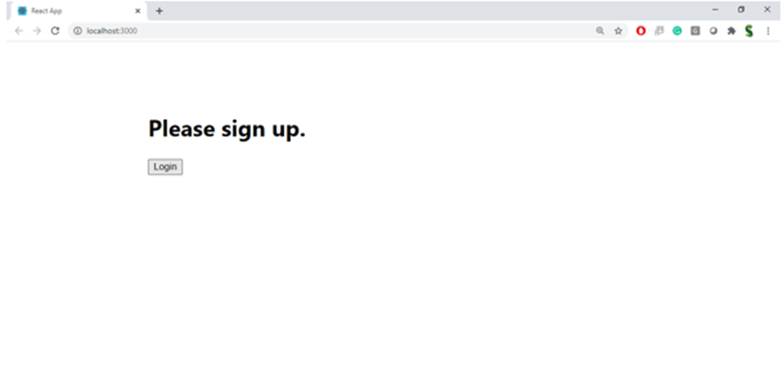

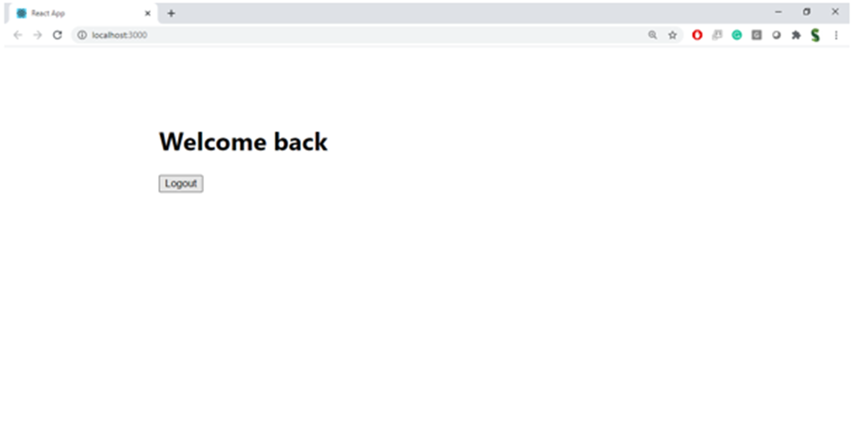

**13.Create a React App named “bloggerapp” with 3 components.**

**1. Book Details**

**2. Blog Details**

**3. Course Details**

### **App.js**

CopyEdit

import React, { useState } from 'react';

import BookDetails from './components/BookDetails';

import BlogDetails from './components/BlogDetails';

import CourseDetails from './components/CourseDetails';

const App = () => {

const [selected, setSelected] = useState("books");

const renderComponent = () => {

if (selected === "books") {

return <BookDetails />;

} else if (selected === "blogs") {

return <BlogDetails />;

} else {

return <CourseDetails />;

}

};

return (

<div style={{ padding: '20px' }}>

<h1> Blogger App - Conditional Rendering</h1>

<div style={{ marginBottom: '20px' }}>

<button onClick={() => setSelected("books")}>Show Books</button>

<button onClick={() => setSelected("blogs")}>Show Blogs</button>

<button onClick={() => setSelected("courses")}>Show Courses</button>

</div>

{/* Conditional Rendering Approaches */}

<h2>Using Function</h2>

{renderComponent()}

<h2> Using Ternary Operator</h2>

{selected === "books" ? <BookDetails /> : selected === "blogs" ? <BlogDetails /> : <CourseDetails />}

<h2> Using Logical && Operator</h2>

{selected === "books" && <BookDetails />}

{selected === "blogs" && <BlogDetails />}

{selected === "courses" && <CourseDetails />}

</div>

);

};

export default App;

**components/BookDetails.js**

javascript

CopyEdit

import React from 'react';

const books = [

{ id: 1, title: "React Explained", author: "Zac Gordon" },

{ id: 2, title: "Learning JavaScript", author: "Ethan Brown" },

{ id: 3, title: "Eloquent JS", author: "Marijn Haverbeke" }

];

const BookDetails = () => {

return (

<div>

<h3> Book Details</h3>

<ul>

{books.map(book => (

<li key={book.id}>

{book.title} by <em>{book.author}</em>

</li>

))}

</ul>

</div>

);

};

export default BookDetails;

**components/BlogDetails.js**

javascript

CopyEdit

import React from 'react';

const blogs = [

{ id: 101, title: "Mastering React Hooks" },

{ id: 102, title: "JavaScript Closures Explained" },

{ id: 103, title: "Understanding ES6 Features" }

];

const BlogDetails = () => {

return (

<div>

<h3> Blog Details</h3>

<ul>

{blogs.map(blog => (

<li key={blog.id}>{blog.title}</li>

))}

</ul>

</div>

);

};

export default BlogDetails;

**components/CourseDetails.js**

javascript

CopyEdit

import React from 'react';

const courses = [

{ id: 'A', name: "Full Stack Developer", duration: "6 months" },

{ id: 'B', name: "Frontend React", duration: "3 months" },

{ id: 'C', name: "Node.js Backend", duration: "2 months" }

];

const CourseDetails = () => {

return (

<div>

<h3> Course Details</h3>

<ul>

{courses.map(course => (

<li key={course.id}>

{course.name} - <strong>{course.duration}</strong>

</li>

))}

</ul>

</div>

);

};

export default CourseDetails;

**index.js**

javascript

CopyEdit

import React from 'react';

import ReactDOM from 'react-dom/client';

import App from './App';

const root = ReactDOM.createRoot(document.getElementById('root'));

root.render(<App />);

**Output:**

